NAME:……………………………………………………….ADM:…………………..CLASS:……….
CHEMISTRY FORM 1
TIME: 1HR 45 MIN
TERM 2 2022 OPENER EXAM FORM 1
TIME:

ANSWER ALL THE QUESTIONS

1a. What is chemistry? (1mk)

b. State two roles of chemistry in our society? (2mks)

2. Outline any five laboratory safety rules (5mks)

3a What is a flame? [1mk]

b. The following diagram represents a non – luminous flame of a Bunsen burner.

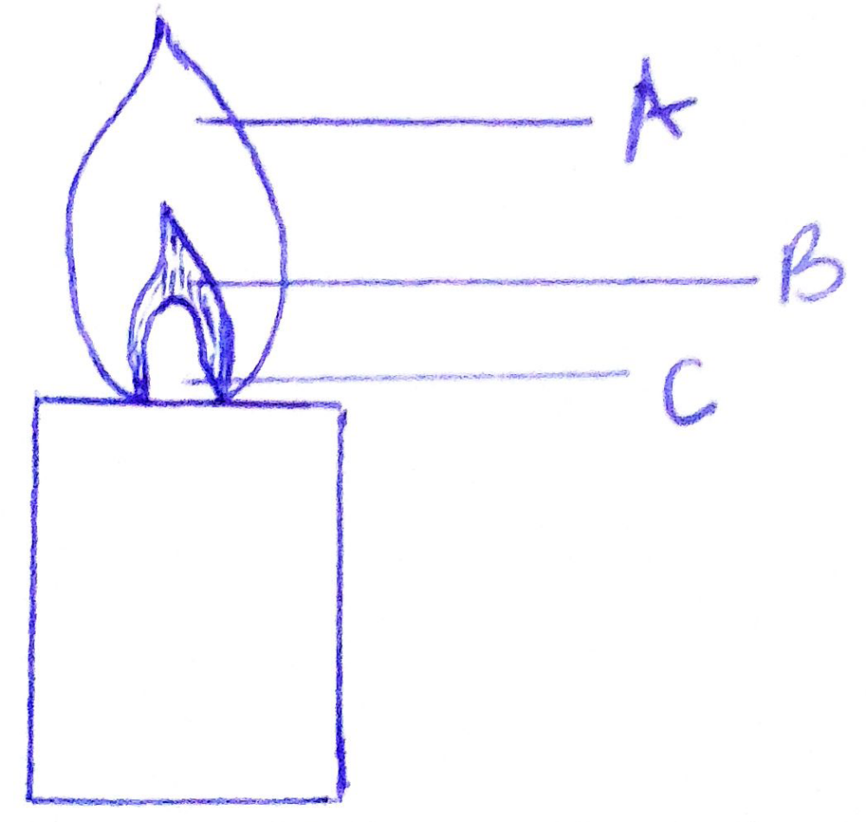

- State the colour of the parts of the flame labelled A,B and C (3mks)

- Which of the parts in (i) above is the hottest? (1mk)

- Why is non-luminous flame preferred for heating? (2mk)

- a. Name the other type of flame produced by the Bunsen burner. [1mk]

b. Under what condition does the bunsen burner produce the flame you named in (a) above (1mk)

4a. Explain why most laboratory apparatus are made of glass. (4mks)

b. Identify the following laboratory apparatus (3mks)

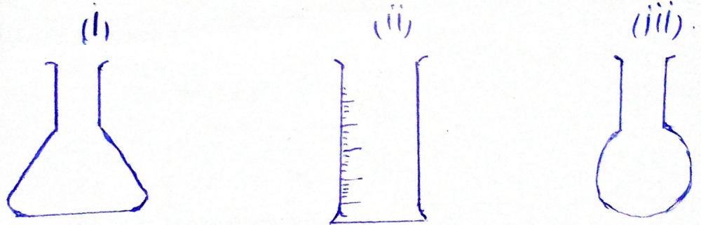

5a. Define matter. (1mk)

b. Give 3 states of matter. (3mks)

c. Identify the physical process in the diagram below. (6mks)

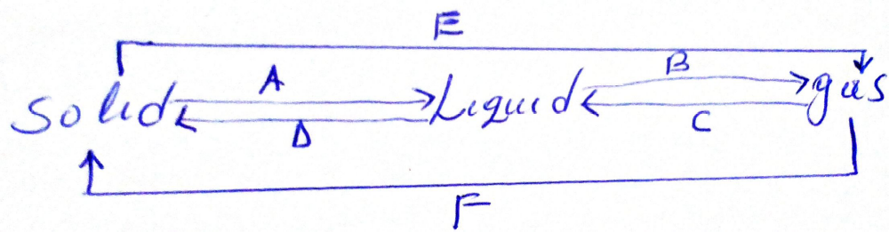

A D
B E
C F
d. State the differences between solid, liquid and gases (3mks)

6a. identify the laboratory apparatus below and label the parts. [6mks]

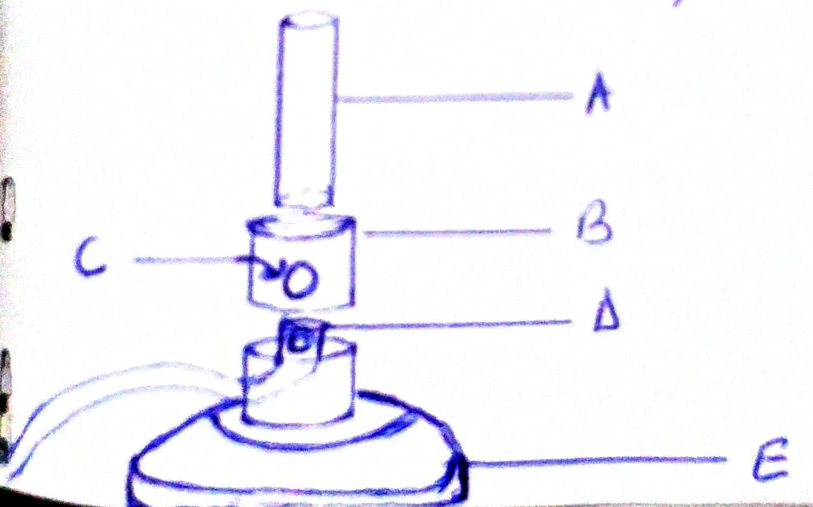

7a. Define the following terms
- mixture (1mk)

- Compound (1mk)

- Element (1mk)

b. Name 2
(i) Mixtures [2mks]

(ii) Compounds [2mks]

- Elements [2mks]

c. List three differences between temporary and permanent changes. (3mks)

d. Give three examples of:
(i) Temporary physical change (3mks)

(ii) Permanent change (3mks)

e. what are the chemical symbols of the following elements:
(i) Copper

(ii)Sodium

(iii)Potassium

7a. Name the elements present in the following compounds. (6mks)
- Iron Sulphide

- Copper (ii) Sulphate

- Sodium Sulphite

